8.47 Main question

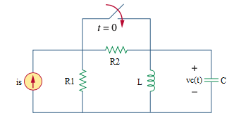

Given is = 3 A, r1= 2 Ω, r2= 10 Ω, c = 10 mF, l= 1 H

Find

Variables

Random variables

is = {1:10};

r2 = {1:20};

Global variables

#is = 3; r1 = 2; r2 = 10; c = 0.01;

l = 1; time = 1;

# t = 0-

vc0 = 0;

il0 = (is*r1)/(r1+r2);

# t = 0+

alpha = 1/(2*r1*c);

w0 = 1/sqrt(l*c);

s1 = -alpha-sqrt(alpha*alpha - w0*w0);

s2 = -alpha+sqrt(alpha*alpha - w0*w0);

A1 = (il0-is-vc0/(l*s2))/(1-s1/s2);

A2 = (il0-is-vc0/(l*s1))/(-s2/s1+1);

vct = l*(s1*A1*exp(s1*time) + s2*A2*exp(s2*time));

Part (กรอกคำตอบ)

1. *vc*(0-) = vc0 = 0 V

2. *vc*(0+) = vc0 = 0 V

3. *α* = alpha = 25 s^-1

4. *ω*0 = w0 = 10 rad/s

At *t* > 0

5. *vc*(*t*) = l*(s1*A1*exp(s1*t) + s2*A2*exp(s2*t))

= (-47.9129)*(0.1139)*exp(-47.9129*t)+(-2.0871)*(-2.6139)*exp(-2.0871*t) V

6. *vc*(time*τ*) = vct = 0.6767 V

8.50 Main question

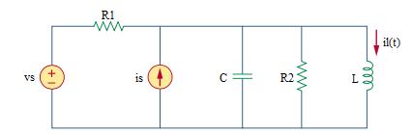

Given vs = 30 V, is = 6u(t) A, r1= 10 Ω, r2= 40 Ω, c = 10 mF, l= 4 H

Find

Variables

Random variables

vs = {10:30};

Global variables

#vs = 30; is = 6; r1 = 10; r2 = 40; c = 0.01;

l = 4; time = 1;

# t = 0-

il0 = vs/r1;

vc0 = 0;

# t = 0+

req = (r1*r2)/(r1+r2);

alpha = 1/(2* req*c);

w0 = 1/sqrt(l*c);

s1 = -alpha-sqrt(alpha*alpha - w0*w0);

s2 = -alpha+sqrt(alpha*alpha - w0*w0);

ia = is+vs/r1;

A1 = (il0-ia-vc0/(l*s2))/(1-s1/s2);

A2 = (il0-ia-vc0/(l*s1))/(-s2/s1+1);

ilt = ia + A1*exp(s1*time) + A2*exp(s2*time);

Part (กรอกคำตอบ)

1. *vc*(0-) = vc0 = 0 V

2. *vc*(0+) = vc0 = 0 V

3. *α* = alpha = 6.25 s^-1

4. *ω*0 = w0 = 5 rad/s

At *t* > 0

5. *il*(*t*) = if + A1*exp(s1*t) + A2*exp(s2*t)

= 9+2*exp(-10t)-8*exp(-2.5t) A

6. *il*(time*τ*) = ilt = 8.3434 A

8.48 Main question

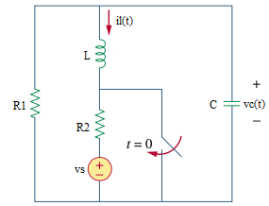

Given vs = 6 V, r1= 1 Ω, r2= 2 Ω, c = 1/4 F, l= 1 H

Find

Variables

Random variables

vs = {1:20};

Global variables

#vs = 6; r1 = 1; r2 = 2; c = 1/4;

l = 1; time = 1;

# t = 0-

il0 = -vs/(r1+r2);

vc0 = -il0*r1;

# t = 0+

alpha = 1/(2*r1*c);

w0 = 1/sqrt(l*c);

A1 = vc0/l+alpha*A2;

A2 = il0;

ilt = (A2+A1*time)*exp(-alpha*time);

Part (กรอกคำตอบ)

1. *il*(0-) = il0 = -2 A

2. *il*(0+) = il0 = -2 A

3. *α* = alpha = 2 s^-1

4. *ω*0 = w0 = 2 rad/s

At *t* > 0

5. *il*(*t*) = (A2+A1*t)*exp(-alpha*t)

= (-2-2*t)*exp(-2*t) A

6. *il*(time*τ*) = ilt = -0.5413 A

8.49 Main question

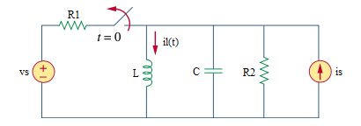

Given vs = 12 V, is = 3 A, r1= 4 Ω, r2= 5 Ω, c = 1/20 F, l= 5 H

Find

Variables

Random variables

vs = {10:20};

is = {1:10};

Global variables

#vs = 12; is = 3; r1 = 4; r2 = 5; c = 1/20;

l = 5; time = 1;

# t = 0-

il0 = is+vs/r1;

vc0 = 0;

# t = 0+

alpha = 1/(2*r2*c);

w0 = 1/sqrt(l*c);

A1 = vc0/l+alpha*A2;

A2 = il0-is;

ilt = is+(A2+A1*time)*exp(-alpha*time);

Part (กรอกคำตอบ)

1. *vc*(0-) = vc0 = 0 V

2. *vc*(0+) = vc0 = 0 V

3. *α* = alpha = 2 s^-1

4. *ω*0 = w0 = 2 rad/s

At *t* > 0

5. *il*(*t*) = is+(A2+A1*t)*exp(-alpha*t)

= 3+(3+6*t)*exp(-2*t) A

6. *il*(time*τ*) = ilt = 4.218 A

8.45 Main question

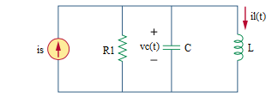

Given is = 4u(t) A, r1= 2 Ω, c = 0.5 F, l= 1 H, *vc*(0-) = 0 V, *il*(0-) = 1 A.

Find

Variables

Random variables

r1 = {2:10};

Global variables

#is = 4; r1 = 2; c = 0.5;

l = 1; time = 1;

# t = 0-

il0 = 1;

vc0 = 0;

# t = 0+

alpha = 1/(2*r1*c);

w0 = 1/sqrt(l*c);

wd = sqrt(w0*w0-alpha*alpha);

A1 = il0-is;

A2 = (vc0/l+alpha(il0-is))/wd;

vct = l*(wd*(-A1*sin(wd*time)+A2*cos(wd*time))*exp(-alpha*time) + (-alpha)*(A1*cos(wd*time)+A2*sin(wd*time))*exp(-alpha*time));

Part (กรอกคำตอบ)

1. *vc*(0-) = vc0 = 0V

2. *vc*(0+) = vc0 = 0 V

3. *α* = alpha = 0.5 s^-1

4. *ω*0 = w0 = 1.414 rad/s

At *t* > 0

5. *vc*(*t*) = l*(wd*(-A1*sin(wd*t)+A2*cos(wd*t))*exp(-alpha*t) + (-alpha)*(A1*cos(wd*t)+A2*sin(wd*t))*exp(-alpha*t))

= 4.536*sin(1.3229*t)*exp(-t/2) V

6. *vc*(time*τ*) = vct = 2.6671 V

8.46 Main question

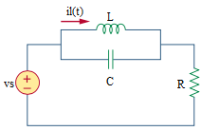

Given vs = 12u(t) V, r = 2 kΩ, c = 5 µF, l= 8 mH

Find

Variables

Random variables

r1 = {2000:10000:1000};

l = {0.001:0.008: 0.001};

Global variables

#vs = 12; r1 = 2000; c = 0.000005;

l = 0.008; time = 1;

# t = 0-

il0 = 0;

vc0 = 0;

# t = 0+

alpha = 1/(2*r1*c);

w0 = 1/sqrt(l*c);

wd = sqrt(w0*w0-alpha*alpha);

is = vs/r1;

A1 = il0-is;

A2 = (vc0/l+alpha*(il0-is))/wd;

ilt = is+(A1*cos(wd*time) + A2*sin(wd*time))*exp(-alpha*time);

Part (กรอกคำตอบ)

1. *vc*(0-) = vc0 = 0 V

2. *vc*(0+) = vc0 = 0 V

3. *α* = alpha = 50 s^-1

4. *ω*0 = w0 = 5000 rad/s

At *t* > 0

5. *il*(*t*) = is+(A1*cos(wd*t) + A2*sin(wd*t))*exp(-alpha*t)

= 0.006-(0.006*cos(5000*t) + 0.00006*sin(5000*t))*exp(-50*t) A

6. *il*(time*τ*) = ilt = 0.006 A